Unity

The dude functional specification

Contributors:

|  |  |
| --- | --- |
| Contributors: | Contact information: |
| Joshua Merz | [s-merzj@bsd405.org](mailto:s-merzj@bsd405.org) |
| Strummer Lavassar | [s-Lavassars@bsd405.org](mailto:s-Lavassars@bsd405.org) |
| Jack Nieman | s-[NiemanJ@bsd405.org](mailto:NiemanJ@bsd405.org) |

|  |
| --- |
| Version |
| 1.2 |
| Author | Date | Version | Comments |
| Joshua Merz | Apr 2nd | 1.0 | Initial Draft |
| Joshua Merz | Apr 10 | 1.2 | feedback from first Sprint review |

Table of Contents

1 Feature Description 2

3 Project Information 7

4 Future Implementation 8

5 Depricated Features 9

What are we making?

We decided to go with a videogame for our next project and more specifically a platformer.

Why?

We have more experience making a videogame because we both took AP computer science and a game development course as a result; we can create a higher quality final product if we already have the necessary skills to complete the task. This fact was evident from the last project where we had no experience creating a website, so we wasted time finding a design environment and learning a new programming language.

Where to start?

First things first we need to create a project and the sprites needed for the game to function, so we made the Player, background, ground, and obstacles.

Background:

Player:

Enemy:

What next?

We need to add these things on to the scene and create basic gameplay/allow the player to move so that the game is playable.

Scene:

Scripts Scripts Scripts!

Now we need to flush out the basic gameplay and make the game playable by making the player health, spike, and enemy behavior Scripts. This will make the game more fun by adding obstacles for the player to avoid proceeding further into the level.

UI

The UI is necessary for any game and is incredibly flexible allowing the player to know how much health they must letting them:

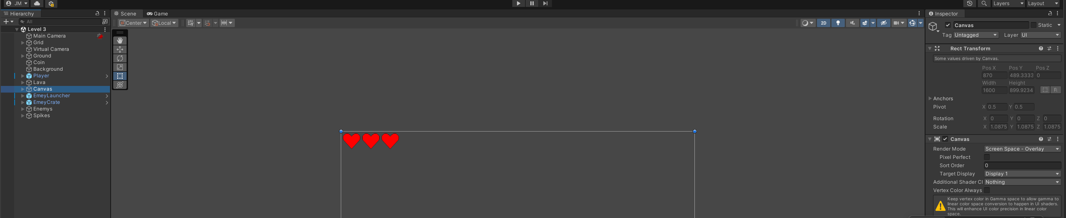

Now we need the player to have the ability to select the level they want to play and be able to move between scenes.

Now we can make a main menu:

A game over screen:

And a Setting scene for later

Now we will fill the previous levels with actual game design elements mentioned above:

Level one:

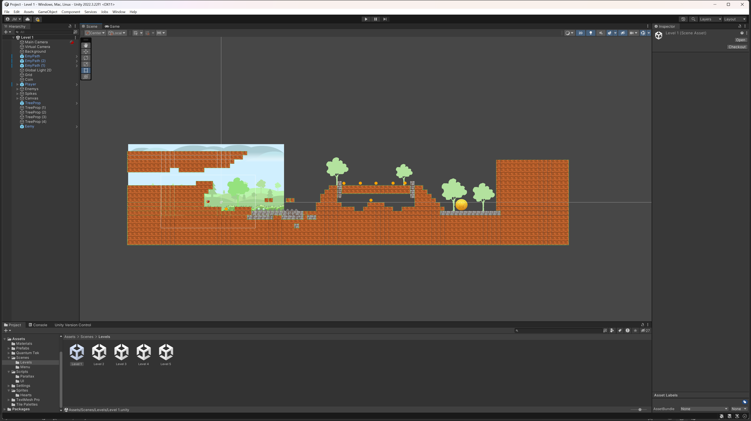

Level two:

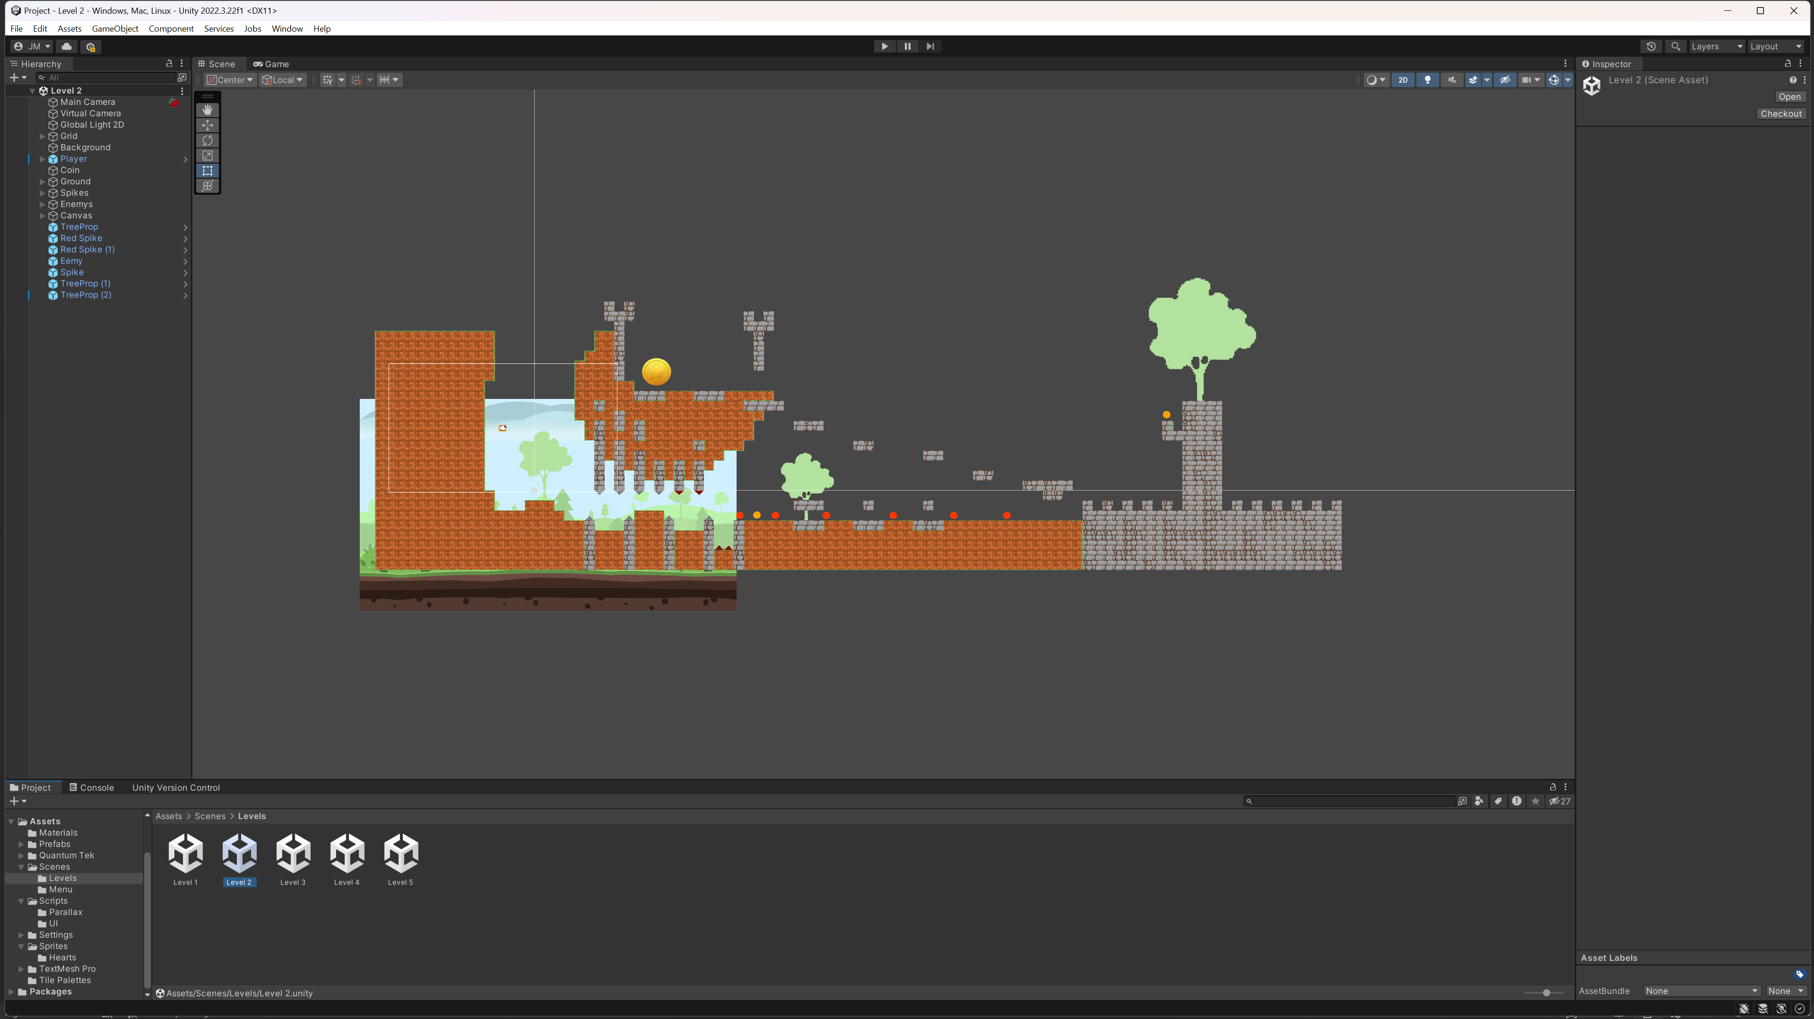

Level three (Strummer and Jack found it funny that I misspelled enemy and emey):

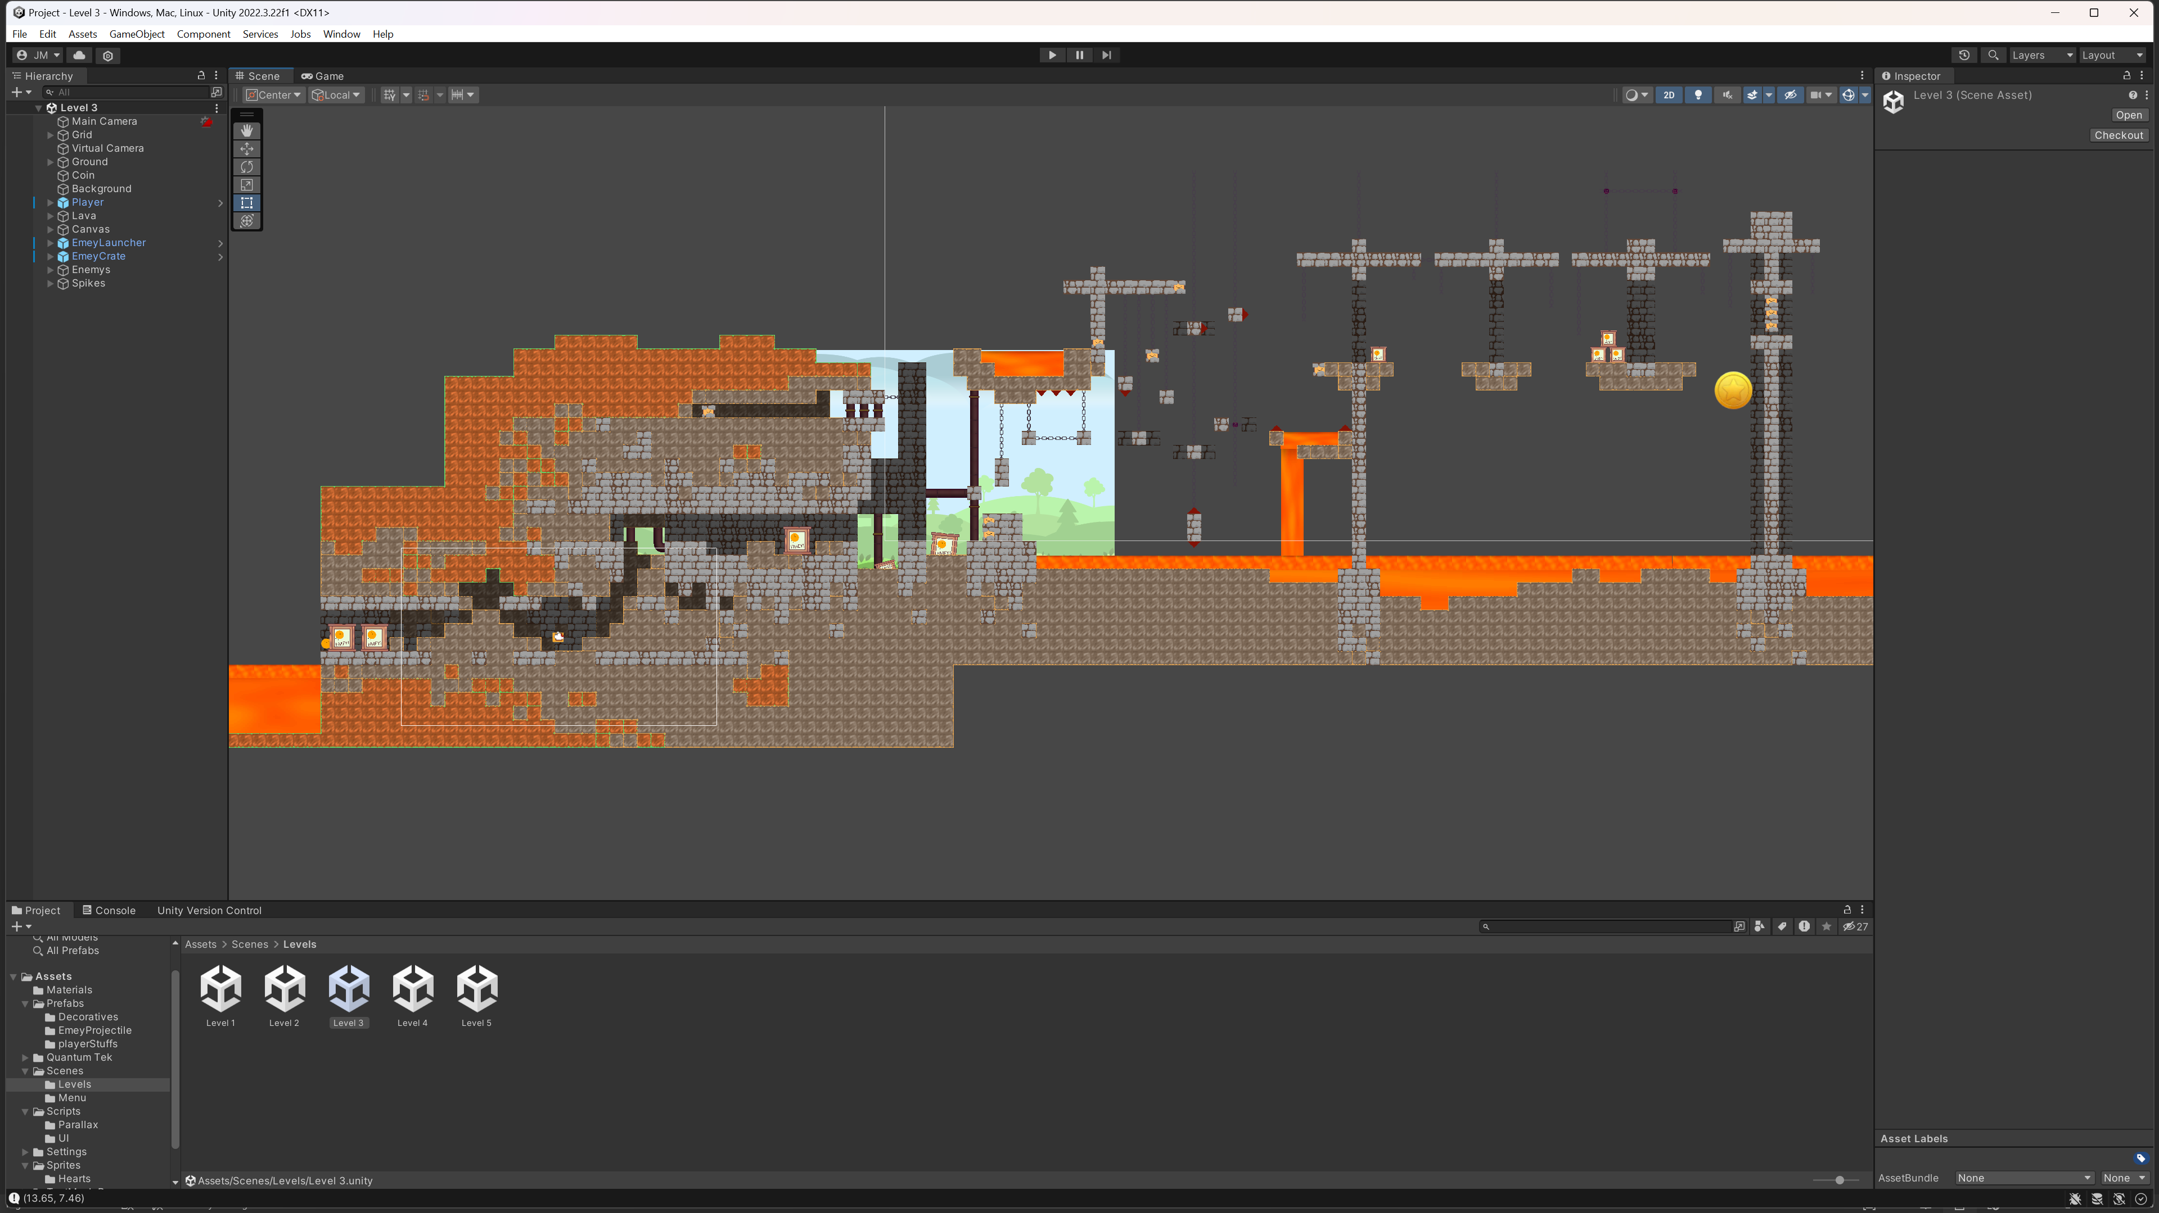

Level four:

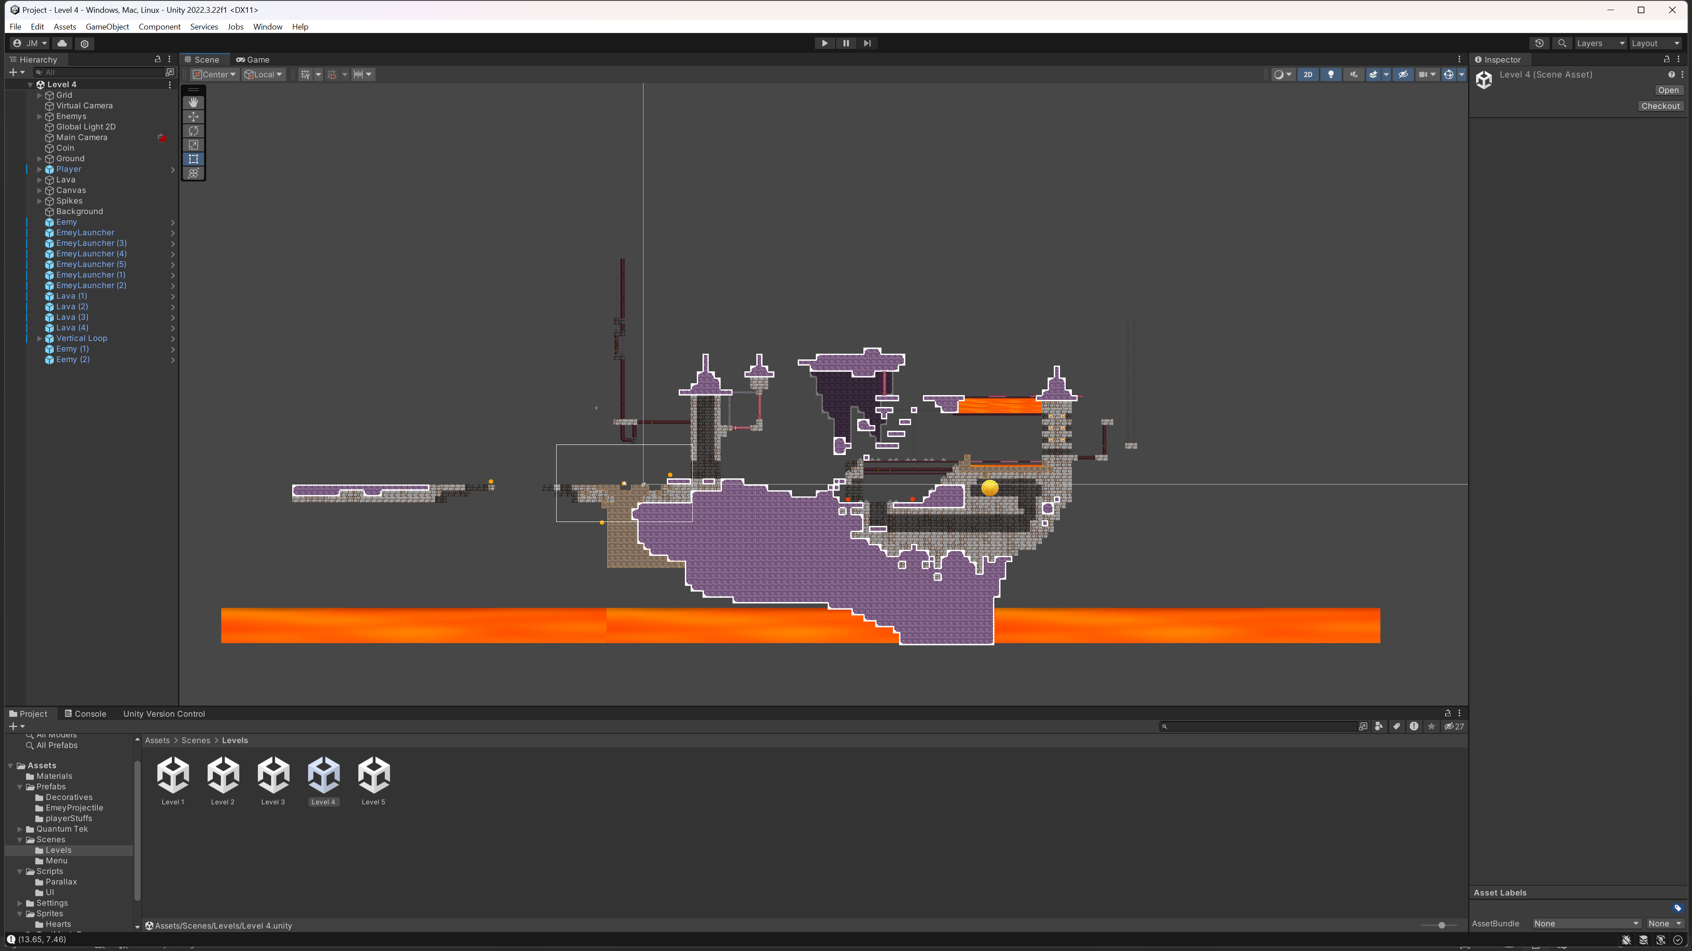

Level Five:

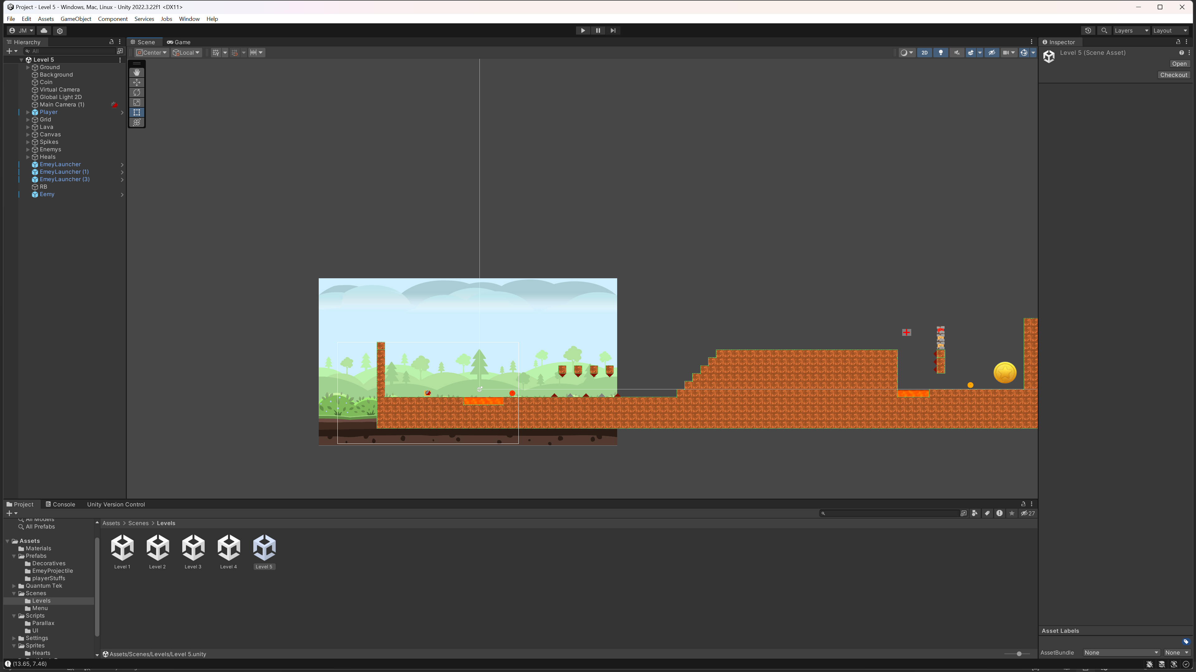

To Do:

Create smooth animations for the enemy and player flipping directions. Creating a settings scene/sprite add new enemy’s, create a sense of progression by preventing the payer from playing a level they have not beaten yet and more levels, add sound effects, (create more levels at least 10), and add new features like a double jump e.c.t...

Deprecated features:

Some features never made it into the final version of the game. Scripts: Parallax layer, camera and background Sprites include the cloud and a blue version of the enemy (he was supposed to be the final boss):

